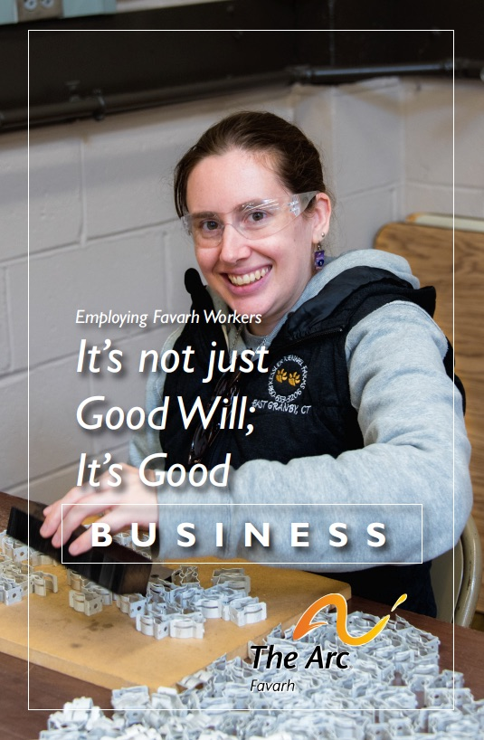

Learn about Favarh’s employment programs
by reading our newest booklet!

https://view.publitas.com/rotary-of-avon-canton-connecticut-usa/favarh-booklet-single-pages-fsm/

